Assignment 1

Contents

Question 1 2

R Command: 2

R output: 2

Question 2 3

R Command: 3

R output: 3

Question 3 3

R Command: 3

R output: 3

Question 4 3

R Command: 3

R output: 3

Question 5 3

R Command: 3

R output: 4

Question 6 4

R Command: 4

R output: 4

Question 7 4

R Command: 4

R output: 4

Question 8 5

R Command: 5

R output: 5

Question 9 6

R Command: 6

R output: 6

Question 10 7

R Command: 7

R output: 7

Subjective arguments: 8

# Question 1

## R Command:

> quest1 <- data.frame (price=housing$price, lotsize=housing$lotsize, bedrooms=housing$bedrooms)

## R output:

**> quest1**

**price lotsize bedrooms**

**1 42000 5850 3**

**2 38500 4000 2**

**3 49500 3060 3**

**4 60500 6650 3**

**5 61000 6360 2**

**6 66000 4160 3**

**7 66000 3880 3**

**8 69000 4160 3**

**9 83800 4800 3**

**10 88500 5500 3**

**11 90000 7200 3**

**12 30500 3000 2**

**13 27000 1700 3**

**14 36000 2880 3**

**15 37000 3600 2**

**16 37900 3185 2**

**17 40500 3300 3**

**18 40750 5200 4**

**19 45000 3450 1**

**20 45000 3986 2**

**[ reached getOption("max.print") -- omitted 526 rows ]**

# Question 2

## R Command:

> price_4beds <- subset(housing, bedrooms==4)

> mean(price_4beds$price)

## R output:

**[1] 81853.68**

# Question 3

## R Command:

> price_per_lotsize <- housing$price/housing$lotsize

> summary(price_per_lotsize)

## R output:

**Min. 1st Qu. Median Mean 3rd Qu. Max.**

**3.863 10.648 13.613 14.194 16.917 37.714**

# Question 4

## R Command:

> stories.summary <- aggregate( housing$price, by=list(housing$stories), FUN = function(x) c(count=length(x), avg=mean(x),median=median(x),max=max(x)))

> stories.summary

## R output:

**Group.1 x.count x.avg x.median x.max**

**1 1 227.00 59580.84 55000.00 155000.00**

**2 2 238.00 68058.19 61550.00 175000.00**

**3 3 40.00 81240.00 83450.00 190000.00**

**4 4 41.00 102977.85 105000.00 175000.00**

# Question 5

## R Command:

> lot_bn_4k_6k<- subset(housing, lotsize >= 4000 & lotsize <= 6000)

> length(lot_bn_4k_6k$lotsize)

## R output:

**[1] 193**

# Question 6

## R Command:

> highest_10_lots <- housing[rev(order(housing$lotsize)),]

> highest_10_lots [1:10,2]

## R output:

**# A tibble: 10 x 1**

**lotsize**

**<dbl>**

**1 16200**

**2 15600**

**3 13200**

**4 13200**

**5 12944**

**6 12900**

**7 12090**

**8 11460**

**9 11440**

**10 11410**

# Question 7

## R Command:

> coeff_variation <- aggregate(housing$price, by= list(housing$airco), FUN = function(x) c(cov=sd(x)/mean(x)))

> coeff_variation

## R output:

**Group.1 x**

**1 no 0.3563295**

**2 yes 0.3314304**

# Question 8

## R Command:

> boxplot(housing$price[housing$prefarea=='yes'], housing$price[housing$prefarea=='no'], names = c('Preferred Area', 'Non-preferred Area'))

## R output:

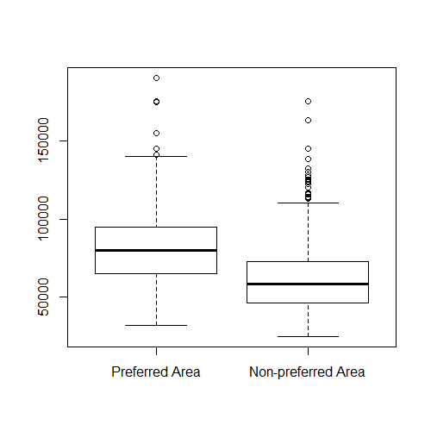

# Question 9

## R Command:

> plot(housing$price, housing$lotsize, xlab = "Price", ylab = "Lot size")

> cor(housing$price,housing$lotsize)

## R output:

**[1] 0.5357957**

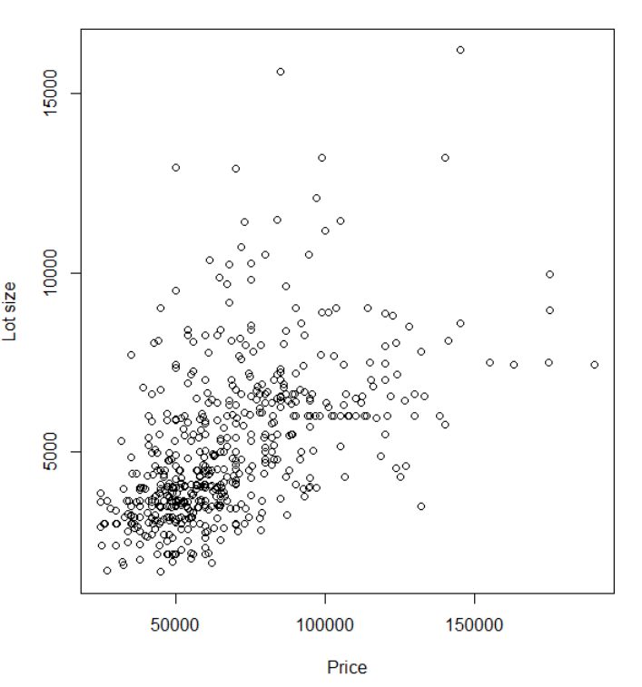

# Question 10

## R Command:

> par(mfrow=c(2,2))

> plot(housing$price[housing$stories==1],housing$lotsize[housing$stories==1], xlab = "Price", ylab = "Lot Size", main="One storey house")

> plot(housing$price[housing$stories==2],housing$lotsize[housing$stories==2], xlab = "Price", ylab = "Lot Size", main="Two storey house")

> plot(housing$price[housing$stories==3],housing$lotsize[housing$stories==3], xlab = "Price", ylab = "Lot Size", main="Three storey house")

> plot(housing$price[housing$stories==4],housing$lotsize[housing$stories==4], xlab = "Price", ylab = "Lot Size", main="Four storey house")

## R output:

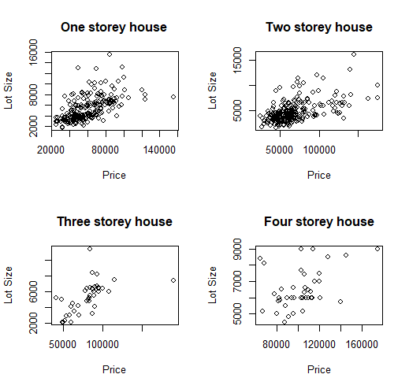

## Subjective arguments:

> cor(housing$price[housing$stories==1],housing$lotsize[housing$stories==1])

[1] 0.5824472

> cor(housing$price[housing$stories==2],housing$lotsize[housing$stories==2])

[1] 0.5466179

> cor(housing$price[housing$stories==3],housing$lotsize[housing$stories==3])

[1] 0.5717948

> cor(housing$price[housing$stories==4],housing$lotsize[housing$stories==4])

[1] 0.3959304

We can see from above plots and the correlation factors that correlation between housing prices and lot size is better correlated for 1, 2 and 3 storied buildings compared 4 storied buildings. The concentration of houses is also less with 3 or 4 storied buildings.

More houses are concentrated before 80k price for 1 storied, 100k for 2 storied buildings. For 3 storied most houses are concentrated between 50k and 100k and for 4 storied it’s between 80k and 120k.